**Adding Elements and Intermediate Array Techniques**

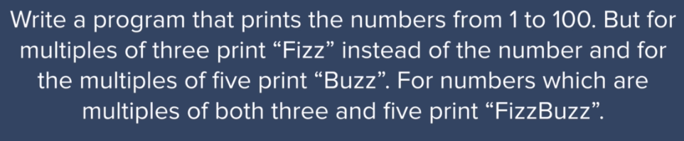

<https://blog.codinghorror.com/why-cant-programmers-program/>

**Code:**

var output = [];

var count = 1;

function fizzBuzz(){

//Write code here

for(count; count<=100; count++){

if(count%3 === 0){

output.push("Fizz");

}

else if(count%5 === 0){

output.push("Buzz");

}

else if(count%3 === 0 && count%5 === 0){

output.push("FizzBuzz");

}

else{

output.push(count);

}

}

console.log(output);

}

//Function Call

fizzBuzz();

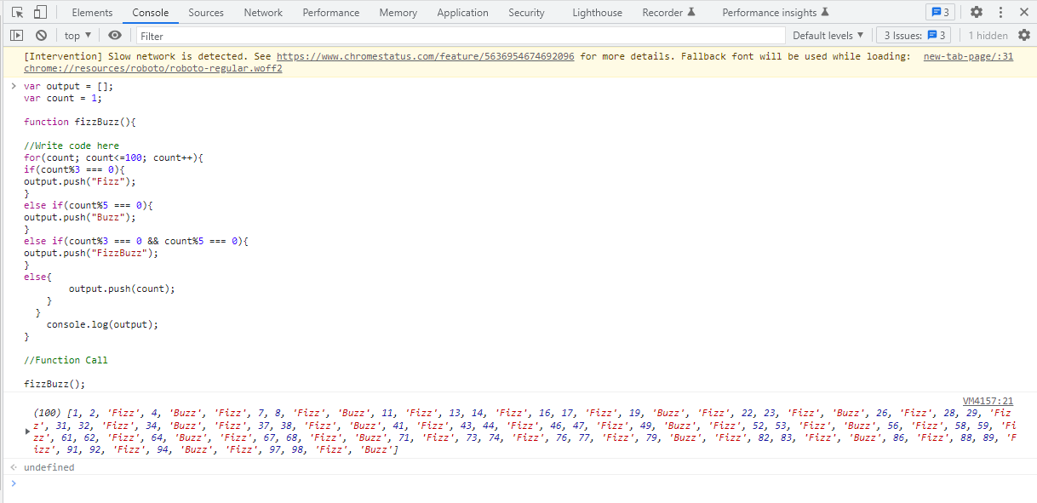

**Control Statements While Loop:**

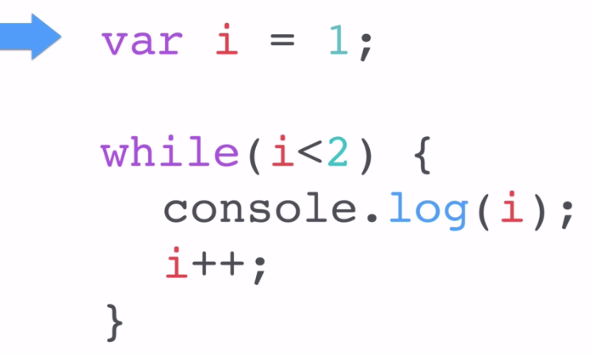

**Code:**

var output = [];

var count = 1;

function fizzBuzz(){

//Write code here

while(count<=100){

if(count%3 === 0){

output.push("Fizz");

}

else if(count%5 === 0){

output.push("Buzz");

}

else if(count%3 === 0 && count%5 === 0){

output.push("FizzBuzz");

}

else{

output.push(count);

}

count++

}

console.log(output);

}

//Function Call

fizzBuzz();

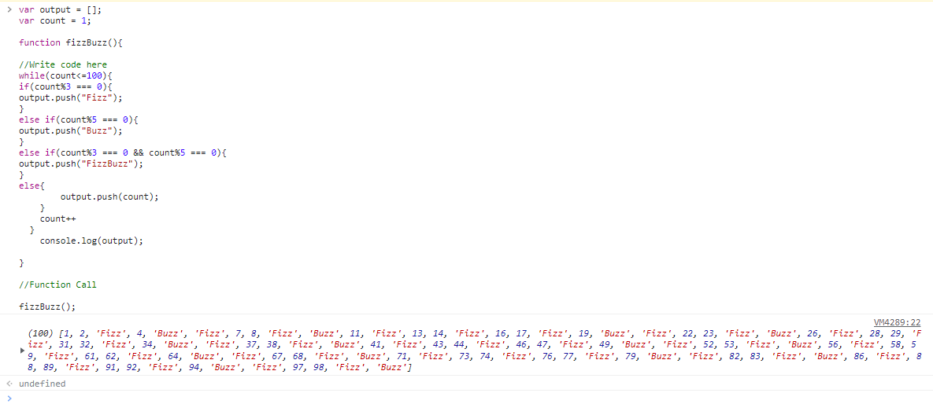

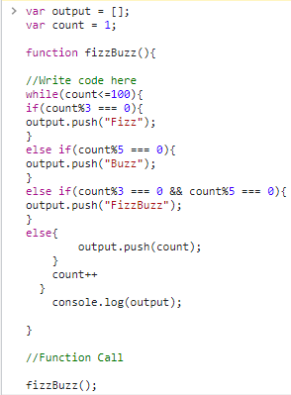

**Infinite Loop:**

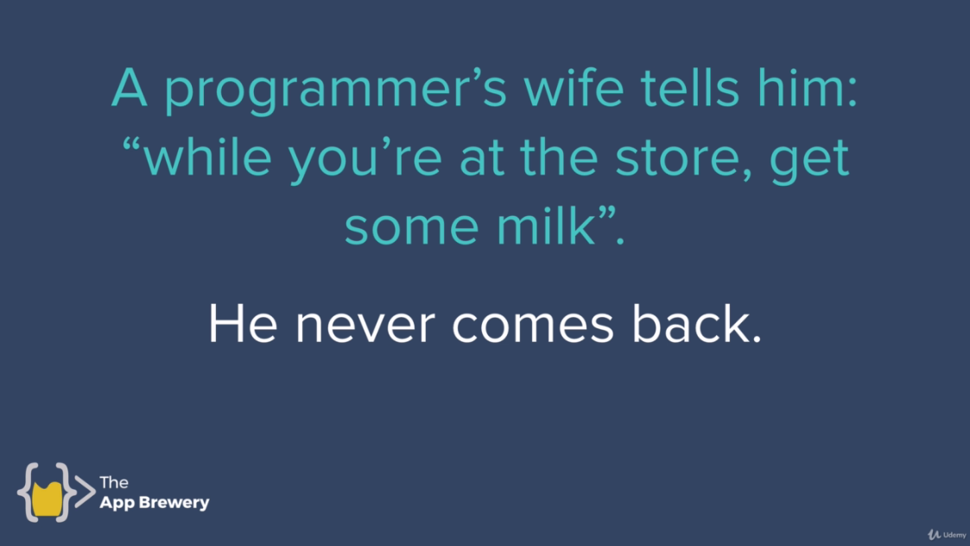

<http://www.99-bottles-of-beer.net/lyrics.html>

**Control Statements for Loop:**

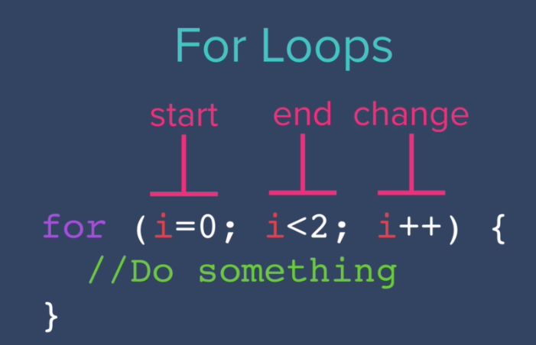

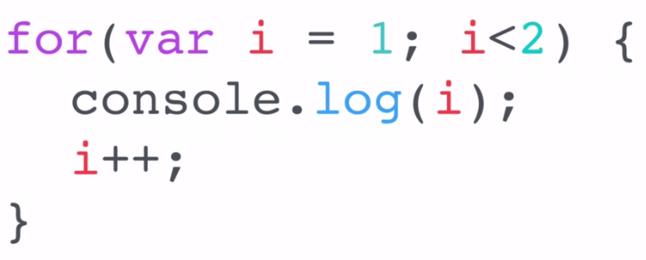

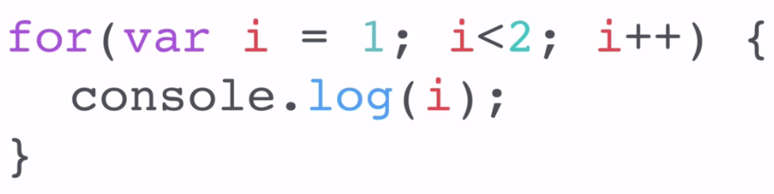

**Code:**

var output = [];

var count = 1;

function fizzBuzz(){

//Write code here

for(count; count<=100; count++){

if(count%3 === 0){

output.push("Fizz");

}

else if(count%5 === 0){

output.push("Buzz");

}

else if(count%3 === 0 && count%5 === 0){

output.push("FizzBuzz");

}

else{

output.push(count);

}

}

console.log(output);

}

//Function Call

fizzBuzz();

